Advanced Data Cleaning and Validation Techniques in Excel

Handling Missing Values
Missing values occur when cells in a dataset contain no data. Handling missing data properly is important because it can affect calculations, reports, and visualizations.
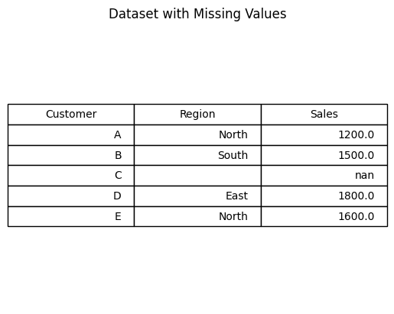

Handling Missing Values in Numerical Variables
Common methods include:
• Replace with Mean (Average)
• Replace with Median (useful when outliers exist)
• Replace with 0 when missing represents no activity
• Remove the row if very few values are missing

Handling Missing Values in Categorical Variables
Common methods include:
• Replace with Mode (most frequent category)
• Replace with 'Unknown' category
• Forward Fill or Backward Fill for time-based datasets

Outlier Detection in Excel
Outliers are values that are significantly higher or lower than the rest of the dataset. Outliers can distort analysis results and should be identified before performing statistical analysis.
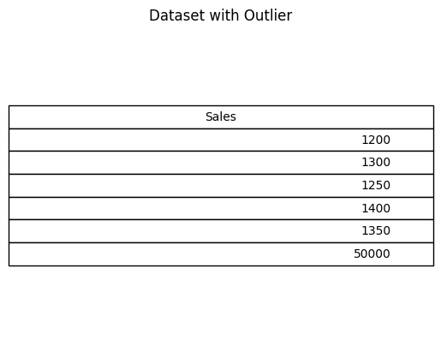
Common techniques to detect outliers:
• Sorting data to identify extreme values
• Using box plots or charts
• Using statistical rules such as IQR method

Data Standardization
Data standardization ensures that data follows a consistent format. This includes fixing capitalization, removing extra spaces, and using consistent naming conventions.
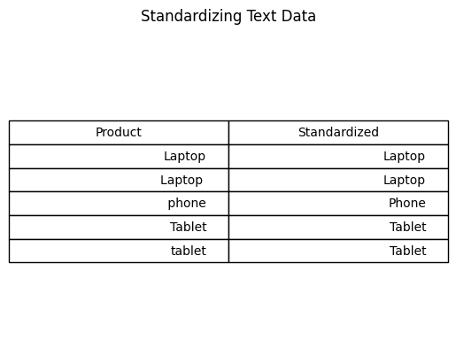
Common standardization practices include:
• Converting text to consistent case (UPPER, LOWER, PROPER)
• Removing extra spaces
• Standardizing product or category names

Text Cleaning Functions in Excel
Excel provides several functions for cleaning text data.

TRIM Function
TRIM removes extra spaces from text except single spaces between words.
Example formula: =TRIM(A2)

CLEAN Function
CLEAN removes non-printable characters that may come from imported datasets.
Example formula: =CLEAN(A2)

SUBSTITUTE Function
SUBSTITUTE replaces specific text with another value.
Example formula: =SUBSTITUTE(A2,"-"," ")
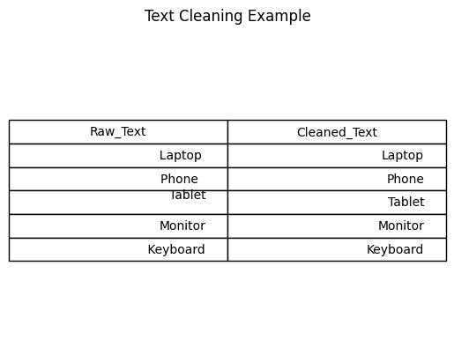

Data Validation in Excel
Data validation restricts the type of data that can be entered into cells. This helps maintain data quality and prevents incorrect entries.
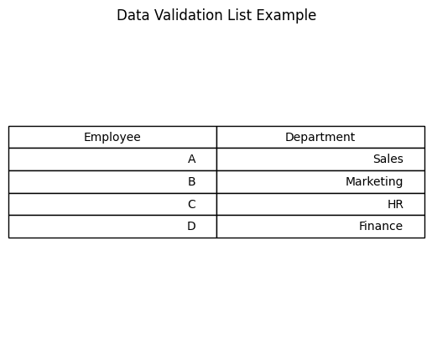

Data Validation Rules for Numerical Data
Examples:
• Restrict values between 1 and 100
• Allow only whole numbers
• Restrict date ranges

Data Validation Rules for Categorical Data
Examples:
• Create dropdown lists for departments or regions
• Restrict allowed values to predefined categories
• Prevent spelling inconsistencies in categories

Conclusion
Advanced data cleaning techniques such as handling missing values, detecting outliers, standardizing data, cleaning text fields, and applying validation rules ensure that datasets are accurate and reliable for analysis.

